Name: ______________________________________________________________ period: ____________

APES Review Packet 2017
(Modified from a document created by the great David Hong)

- Use the axes to the right for the following:
Population
Time
  - Draw and label a line that represents linear growth.
  - Draw and label a line that represents exponential growth.

- List the four most populated countries in the world (in order)

(1) (3)
(2) (4)
- Define the term ecological footprint, what types of countries have low and high ecological footprints?
__________________________________________________________________________________________
__________________________________________________________________________________________
__________________________________________________________________________________________
__________________________________________________________________________________________
- Write an equation for the rule of 70, and what the rule of 70 is used to calculate:

- Perform the following calculations: (Show all of your work in a logical progression to the final answer.)

  - A city has a population of 50,000 in 2012. If the population of the city grows at an annual rate of 2%, the year in which the population will reach 100,000 is _____________ and the year it will reach 200,000 is _____________.
Show ALL work:

  - A country’s population was 12 million in 1992 and in 2012 it is 24 million. If the population grew at a constant rate, that percent rate of growth was _____________.
Show ALL work:

- Complete the following table by writing “high” or “low” in each box below.
Characteristic | More Economically Developed Counties (MEDCs) | Less Economically Developed Countries (LEDCs)
per capita GDP
degree of industrialization
infant mortality rate
per capita fossil fuel use
ecological footprint
greenhouse gas emissions
risk from heart disease
risk from infectious diseases

- Identify three examples of renewable resources and three examples of nonrenewable resources.
(1) (1)
Renewable: (2) Nonrenewable: (2)
(3) (3)

- Define the following:
  - total fertility rate
_____
___________________________________________________________________
  - replacement level fertility

  - infant mortality rate

  - crude birth rate

  - crude death rate

- Describe the circumstances that will result in a Tragedy of the Commons.

__________________________________________________________________________________________
__________________________________________________________________________________________
__________________________________________________________________________________________
__________________________________________________________________________________________
- Describe an example of a Tragedy of the Commons.

__________________________________________________________________________________________
__________________________________________________________________________________________
__________________________________________________________________________________________
__________________________________________________________________________________________

- On the axes to the right, draw a line showing a population that exemplifies logistic growth. (s-curve) and label the carrying capacity.
Population
Time

- Perform the following calculation. Show all of your work:

In a particular year a population has the following characteristics: the crude birth rate is 45, the crude death rate is 20, the immigration rate is 1%, and the emigration rate is 0.5%. The percent rate of growth for that year is __________.
Show ALL work:

- Describe an example of a positive feedback loop.

__________________________________________________________________________________________
__________________________________________________________________________________________
__________________________________________________________________________________________
__________________________________________________________________________________________
- Use the axes below to draw and label lines representing the birth rate, death rate and total population size during the idealized demographic transition of a country. Include, written directly onto the graph, the names of each phase and TWO explanations for each change in the birth rate and death rate for each phase.
Rate / Population size
Time
- On the axes below, draw and completely label four age-structure diagrams that represent slow growth, rapid growth, negative growth, and zero population growth (include labels on the x- and y-axes)

- Describe an example of a negative feedback loop.

__________________________________________________________________________________________
__________________________________________________________________________________________
__________________________________________________________________________________________
__________________________________________________________________________________________

- Arrange the following types of electromagnetic radiation in order from lowest to highest energy: Ultraviolet, Microwave, Infrared, Gamma, Radio, X-ray, Visible.

____________, ____________, ____________, ____________, ____________, ____________, ____________

- List the following types of visible light in order from shortest to longest wavelength: Green, Orange, Red, Yellow, Blue, Violet.

______________, ______________, ______________, ______________, ______________, ______________

- Identify three examples organic compounds and three examples of inorganic compounds.

(1) (1) _______________
Organic: (2) Inorganic: (2) _______________
(3) (3) _______________
Survivorship
Time
- Using the axes on the right, draw and label three survivorship curves exemplifying early-loss, late loss, and constant-loss species. Give two examples of organisms that exhibit each type of survivorship curve

- List three consequences of global warming.

__________________________________

__________________________________

__________________________________
- List three things you could do to decrease your contribution to global warming.
(1)
(2)
(3)
Altitude (km)
Temperature (°C)
- List four greenhouse gases.
(1) _________________ (3) _________________
(2) _________________ (4) _________________

- Use the axes to the right for the following:
  - Draw a line representing the Earth’s atmosphere and label each layer of the Earth’s atmosphere and identify where the greenhouse effect occurs and the ozone layer is situated.

- Humans began agriculture approximately ______________ years ago.
- A man-made product is also known as ______________________.
- The molecular formula of ozone is ________.
- In the box below, write out a series of chemical equations that illustrate the destruction of the ozone in the ozone layer.

- The acronym HCFC refers to ____________ _____________ _____________ _____________, which is:

__________________________________________________________________________________________
__________________________________________________________________________________________
- Identify three examples of biotic and abiotic components of an ecosystem:

- _________________ (1) _________________
Biotic: (2) _________________ Abiotic: (2) _________________
(3) _________________ (3) _________________

- Complete the following table for these biogeochemical cycles:

Trait | Carbon | Nitrogen | Phosphorus | Water
Importance to life
Largest reservoir
Methods of transport
Cycle duration (long/short)
Photosynthesis:
- Write the balanced chemical equations for photosynthesis and respiration in the boxes to the right.
Cellular Respiration:
- The approximate age of the Earth is

____________ years.

- Match the following:
  - generalist species Zebra mussel Galapagos tortoise
  - specialist species
  - invasive species American Alligator Tiger salamander
  - keystone species
  - indicator species Norway rat Giant Panda
  - endemic Species

- Define the term biodiversity.
__________________________________________________________________________________________
__________________________________________________________________________________________

- Define the term biome.
__________________________________________________________________________________________
__________________________________________________________________________________________

- What main factors determine the type of biome an area will have?
__________________________________________________________________________________________
__________________________________________________________________________________________
__________________________________________________________________________________________
- Describe the circumstances that will result in cultural eutrophication.

__________________________________________________________________________________________
__________________________________________________________________________________________
__________________________________________________________________________________________
__________________________________________________________________________________________
__________________________________________________________________________________________

- Explain HOW the increasing concentration of carbon dioxide in the atmosphere leads to ocean acidification. Include a chemical equation in your answer.

__________________________________________________________________________________________
__________________________________________________________________________________________
__________________________________________________________________________________________
__________________________________________________________________________________________

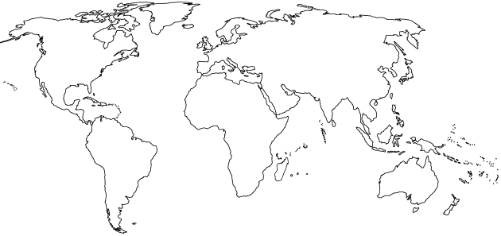
- Sketch and/or label the following on the map of the world below:
  - the equator
  - the tropic of Cancer and the tropic of Capricorn
  - the Mid-Atlantic Ridge
  - the location of suppressed upwelling characteristic of the occurrence of El Niño
  - the location of India, Ethiopia, Brazil, Peru, Saudi Arabia, Indonesia, Japan, Bangladesh, and Fremont ( from the FRQs )
  - Mediterranean Sea, Aral Sea, Red Sea and the Ogallala Aquifer.

- Complete the following table:
Type of Biome | Typical Location | Typical Climate | Characteristic adaptations for survival  (very general)
Tropical Rain Forest |  |  | Plants –  Animals –
Temperate Deciduous Forest |  |  | Plants –  Animals –
Taiga (Boreal) Forest |  |  | Plants –  Animals –
Tropical Grasslands (Savanna) |  |  | Plants –  Animals –
Temperate Grassland (Prairie) |  |  | Plants –  Animals –
Tundra  (Cold Grassland) |  |  | Plants –  Animals –
Desert |  |  | Plants –  Animals –

- Name the following:
NO NO₂
NO₂⁻ NO₃⁻
NO₂ N₂O
N₂ NH₃
NH₄⁺ HNO₃
NO_{x}
- In the box to the right, sketch a house and the surroundings of a house that is designed to make the greatest use of passive solar energy in the northern hemisphere. Include, inside the box, the location of both the winter and summer sun, and labels to indicate the compass direction that the house faces.
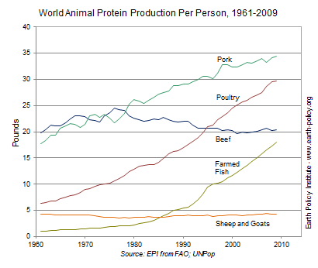
Use the information in the diagram on the right to answer the following:

- The percent change in the per capita global production of protein from poultry between 1980 and 2000 was approximately ______________.
Show work:

- The percent change in the per capita global production of protein from farmed fish between 1980 and 2000 was approximately ____________.
Show work:

- The percent change in the per capita global production of protein from beef between 1961 and 2009 was approximately ___________. Show work:

- The founder of the Sierra Club was ___________ ___________.

- Rachel Carson wrote the book ________ _________to raise people’s awareness of the harmful effects of the
pesticide ______.

- The acronym ENSO refers to _____________ _____________ _____________ _____________, a
phenomenon that occurs in the _____________ Ocean.

- Place the following nine events in chronological order, beginning with the most recent:
Oil spill of the Exxon Valdez; the meltdown of the reactor at Chernobyl; the explosion of the Deepwater Horizon; the discovery of contamination at Love Canal; the leak of methyl isocyanate in Bhopal; the drafting of the Kyoto Protocol; the ratification of the Montreal Protocol, passage of the US Endangered Species Act.

(1) (4) (7)
(2) (5) (8)
(3) (6) (9)
- The acronym BOD refers to __________________ ________________ _________________, which is:

- The acronym GMO refers to __________________ ________________ _________________, which is:

- Perform the following calculation. Show all of your work.
If the grasses on a 100-hectare area of grassland grow at an average rate of 1 cm/day, the average volume of grass that is added to the grassland each day is ____________ m³. If the density of the grasses that grow in the grassland averages 400 kg/m³, the net primary productivity is approximately _____________ g/m²/day or _____________ g/m²/year.
Show work:

- Perform the following calculation. Show all of your work.
A 40 m² solar array is installed on a house where the average insolation is 6 kWh/m²/day if the average total electricity output of the array is 1.2 kWh/hr; the efficiency of the array is ____________.
Show work:

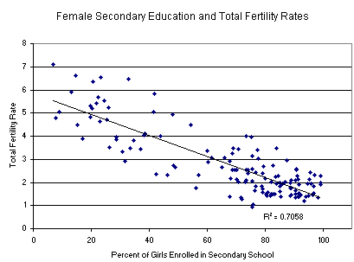

- Consider the graph on the right and explain what can be inferred from the data it presents.

______________________________________________
______________________________________________
______________________________________________
______________________________________________
- The first National Park was ____________________ National Park.

- Match the ten most populous urban areas in the world with its respective continent:

  - Asia Mexico City ____ Seoul
  - N. America
  - S. America Mumbai ____ Los Angeles
  - Africa
  - Australia Sao Paulo ____ Jakarta
  - Europe
  - Antarctica Osaka/Kobe ____ Delhi

Tokyo ____ Shanghai
- Define the following…

Watershed:
__________________________________________________________________________________________
Clean Air Act:
__________________________________________________________________________________________
Clean Water Act:
__________________________________________________________________________________________
Safe Drinking Water Act:
__________________________________________________________________________________________
El Niño:
__________________________________________________________________________________________
Baghouse filter
__________________________________________________________________________________________
Electrostatic precipitator:
__________________________________________________________________________________________
Dioxin:
__________________________________________________________________________________________
- Explain three sources of methane that are amplified by human activities.
(1)
(2)
(3)

- The box to the right contains a crude depiction of a mountain, use it to sketch and label the essential atributes of a rain shadow. Include labels for the direction of the prevailing winds and nearest ocean.

- NO₂ is converted to N₂ and O₂ in a _____________ _____________, which also converts _____ to _____.
- Explain the causes and effects of an urban heat island.

__________________________________________________________________________________________
__________________________________________________________________________________________
__________________________________________________________________________________________
- Perform the following calculations: (Show all of your work.)
  - A rectangular area of forest that measures 10 thousand meters by 300 thousand meters has an area of ___________ square kilometers.
Show work:

  - A 60-Watt light bulb that is used for an average of 4 hours each day uses ___________ kilowatt-hours of electricity per year.
Show work:

- List two characteristics of an r-selected species.
(1) (2)
- List two characteristics of a K-selected species.
(1) (2)
- A Pacific Yew is a/an ____________ and it is endangered because of the following:

- A Piping Plover is a/an ____________ and it is endangered because of the following:

- An Orangutan is a/an ____________ and it is endangered because of the following:

- A Dodo was a/an ____________ and it is extinct because of the following:

- A company is importing rare tropical hardwood to manufacture furniture, list three laws, regulations, treaties, or acts that the company may have violated.

(1)
(2)
(3)
- Whaling is justified in the name of scientific research, by the countries of ___________ and ___________.

- Complete the following table:
Ecosystem Component | An economically valuable ecosystem service it provides
honey bee
water cycle
forest
bat
bacteria
coral reef
wetland

- Two islands, different distances from the mainland have different rates of extinction, this is explained by the theory of island ________________________.
- ________________________ is an ecologically damaging fishing technique typically used to harvest scallops, crabs, and shrimp from the sea floor.
- _____% of the Earth is covered with water. Of all the water on Earth _____% of it is saltwater, _____% is frozen, and _____% is available and relatively accessible.
- Arrange the following particles in order of smallest to largest: clay, sand, silt
(1) (2) (3)

- What are the 3 most commonly produced grains?

(1) (2) (3)

- List four innovations that characterized the Green revolution.
(1) (3)
(2) (4)

- Match the following:
  - anemia iron deficiency
  - goiter vitamin A deficiency
  - scurvy vitamin D deficiency
  - rickets iodine deficiency
  - blindness vitamin C deficiency

- Use the axes below to draw and label an illustration of the pesticide treadmill, make sure to label predator, pest and application of pesticide.
Pest Population
Time
- Explain out the process of the pesticide treadmill and the creation of superbugs.
______________________________________________________________________________________
______________________________________________________________________________________
______________________________________________________________________________________
- Explain how the biomagnification of DDT led to the (near) demise of the Bald Eagle population in the US.

- List three things you could do to conserve water.
(1)
(2)
(3)
- Perform the following calculations: (Show all of your work.)

  - A family of 5 replaces a 6-gallon/minute showerhead with a new 2-gallon/minute low-flow showerhead. If every member of the family takes one 10-minute shower per day, the family will save ___________ gallons of water in one year.
Show work:

  - A family has a rectangular swimming pool that measures 15 feet by 20 feet. If water evaporates from the pool at a rate of 50 gallons per square foot per year and a pool cover will reduce evaporation by 90 percent, the family can save ___________ gallons of water per year by using a pool cover.
Show work:

- Define the following:

pH:
__________________________________________________________________________________________
Turbidity:
__________________________________________________________________________________________
Water hardness:
__________________________________________________________________________________________
Biological oxygen demand:
__________________________________________________________________________________________
Organic waste:
__________________________________________________________________________________________
Cholera:
__________________________________________________________________________________________
Schistosomiasis:
__________________________________________________________________________________________
Giardia:
__________________________________________________________________________________________

- Label the following diagram of a sewage treatment plant and list the items removed at each step.

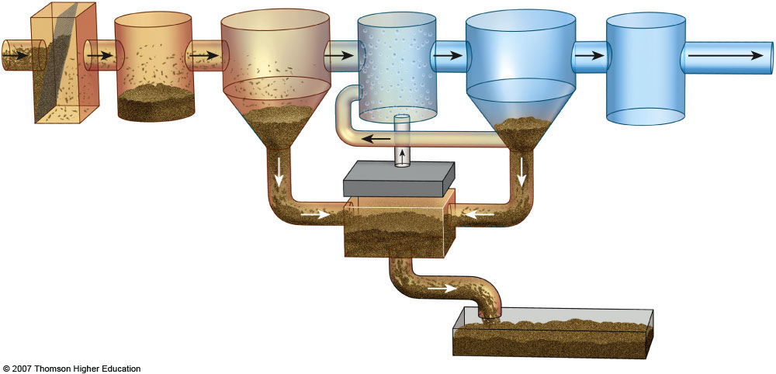

- In the box to the right, list the ranks of coal in order from highest to lowest energy content. (indicate the direction in the box.)
- List three air pollutants that are emitted during the burning of coal.

(1) (2) (3)

- List five products that are derived primarily from crude oil:

_________________, _________________, _________________, _________________, __________________

- The acronym OPEC refers to _____________ _____________ _____________ _____________, which is important because:

- Fracking is a common name for _____________________ ______________ and it is a concern because…

- The acronym ANWR refers to _____________ _____________ _____________ _____________, which is important because:

- The Keystone Pipeline refers to ____________________________________________________which is important because:

- Perform the following calculations: (Show all of your work in a logical progression to the final answer.)
  - A family has a total of 1500 Watts of light bulbs throughout their house, if they replace them all with LED light bulbs, which use 90% less energy, the family will now use _____________ Watts of electricity.
Show work:

  - A space heater operates at 1500 Watts, if it is used for 10 hours each day for one week and the cost of electricity is 20 cents per kilowatt-hour, it will cost _____________ to operate the heater for the week.
Show work:

- The acronym CAFE refers to _____________ _____________ _____________ _____________, which is important because:

- ___________________ is the active element in most photovoltaic cells.

- List four things you could do to conserve energy.
(1)
(2)
(3)
(4)

- Complete the following chart.

Mining Technique | Description | Environmental consequences
Open-Pit mining
Subsurface mining
Strip mining
Mountaintop removal
Ocean Drilling

- Explain what happened at Three Mile Island, and why it is significant.
__________________________________________________________________________________________
__________________________________________________________________________________________
__________________________________________________________________________________________
- Explain how thermal pollution is produced by power plants.
__________________________________________________________________________________________
__________________________________________________________________________________________
__________________________________________________________________________________________
- Explain what happened at Fukushima Daiichi and why it is significant.
__________________________________________________________________________________________
__________________________________________________________________________________________
__________________________________________________________________________________________

- Perform the following calculation. Show all of your work. A radioactive cloud may contain Iodine-131, which has a half-life of 8 days. If the waste must decay to a concentration of less than 0.1% to be considered safe, it will take approximately ______ days to reach safe levels.
Show work:

- Perform the following calculation. (Show all of your work in a logical progression to the final answer.) A family has a 75 m² solar array on their house, which has an efficiency of 10%. If the average insolation on their array is 6 kWh/m²/day and their average cost of electricity is 20 cents per kilowatt-hour, the family has the capacity to produce _________ worth of electricity daily, and _________ annually, from the sun.
Show work:

- For each of the following substances, draw an arrow that points to an unambiguous location along the line, below, representing pH:
orange juice; normal rain; ammonia; lime (calcium carbonate); sulfuric acid; acid rain; human blood.

1 2 3 4 5 6 7 8 9 10 11 12 13 14
pH

- Explain what evapotranspiration is and why it is significant.

- What is different about growing plants hydroponically?

- In the box, write a series of chemical reactions that leads to the formation of tropospheric ozone in photochemical smog.

- The acronym POP refers to _____________ _____________ _____________ which is:

- Explain what a watershed is and why it is significant.
__________________________________________________________________________________________
__________________________________________________________________________________________
__________________________________________________________________________________________

- List two environmental benefits of wetlands.
1)
2)
- Explain how electricity is produced by a dam.

__________________________________________________________________________________________
__________________________________________________________________________________________
__________________________________________________________________________________________

- List four characteristics that will result in waste being classified as “hazardous”

1) 2) 2) _____________ 4) ___________________

- What is a wet scrubber and how does it work?
__________________________________________________________________________________________
__________________________________________________________________________________________
__________________________________________________________________________________________
- In the box below, write a series of chemical reactions that leads to the formation of acid rain.

- Kwaskiorkor is _______________________________________________________________________

- Marasmus is _________________________________________________________________________
- If the cost of gas is $3.50 per gallon and the average gas mileage of a car is 25 mpg, the cost of driving the car per mile is _____________ $/mi, or _____________ ȼ/mi.
Show work:

- The acronym NIMBY refers to _____________ _____________ _____________ _____________ _____________, which is:
- Identify significant sources of the following air pollutants:

Formaldehyde:
Radon:
Mercury:
Carbon monoxide:
Nitrous oxide:
- List three specific health effects of lead on humans.

- What was the Green Revolution and why is it important?

- Label the four major zones of life in the appropriate areas on the diagram representing a temperate lake in the box to the right.

- List three disinfectants that are commonly used to make drinking water safe during in the water treatment process.

1) ____
2) _________________
3) ______

- On the circle to the right, draw out 0, 30, 60 and 90 degree latitude lines. Draw and label the Polar Hadley and Ferrell cells, with the proper circulation pattern for each (clockwise or counterclockwise)

- In the box below, write the chemical equation for the formation of carbonic acid from the reaction of water with carbon dioxide.

- Identify two places in the environment where the above reaction occurs naturally.

1)
2)

